Cardiovascular Disease Prediction with Explainable AI
GitHub Repository: https://github.com/Mazen-980/XAI-Research-paper/tree/main

Abstract
This report combines the four team notebooks focused on the three required deliverables: exploratory data analysis (EDA), model results, and interpretability techniques with their findings. All notebooks address binary cardiovascular disease prediction from a processed tabular dataset containing demographic, blood-pressure, clinical, lifestyle, and engineered risk features. The team explored broad benchmark models, tuned XGBoost, boosted-tree ensembles, a stacking architecture, and multiple explainability tools such as SHAP, LIME, permutation importance, PDP, ICE, RFE, and VIF. Across the notebooks, the most stable medical signals were age, systolic and diastolic blood pressure, cholesterol, glucose, and engineered blood-pressure interaction features.

1. Project Overview
The team approached the same cardiovascular disease prediction task from four complementary angles. The first notebook built a broad benchmark pipeline comparing classical machine learning models and a modified 1D CNN on both base and engineered feature sets. The second notebook focused on paper selection, tuned XGBoost, and SHAP-based analysis inspired by Ogunpola et al. (2024). The third notebook adapted Shah et al. (2025) using boosted-tree models, a soft voting ensemble, SMOTE, and broader explainability. The fourth notebook implemented Logistic Regression, SVM, and a stacking ensemble with additional local and global XAI techniques.
- Shared task: binary classification of cardiovascular disease risk.
- Shared evaluation focus: accuracy, recall, F1-score, ROC-AUC, and clinical interpretability.
- Shared XAI goal: explain not only which features matter globally, but also why individual predictions move toward disease or no disease.

2. Dataset Overview
The combined reports describe the working data as a processed cardiovascular disease dataset with approximately 68.7 thousand usable records and an initial 12-column structure. The target column is a binary cardiovascular disease label, and the core predictors include age, gender, height, weight, systolic pressure (AP_HIGH), diastolic pressure (AP_LOW), cholesterol, glucose, smoking, alcohol use, and physical activity. Several notebooks then extended this core representation using medically meaningful engineered features such as BMI, pulse pressure, mean arterial pressure, age-pressure interactions, metabolic risk, and blood pressure–cholesterol interactions.
Feature group | Variables repeatedly used across notebooks
Demographic / body measures | AGE, GENDER, HEIGHT, WEIGHT
Blood pressure | AP_HIGH, AP_LOW
Clinical indicators | CHOLESTEROL, GLUCOSE
Lifestyle indicators | SMOKE, ALCOHOL, PHYSICAL_ACTIVITY
Engineered risk variables | BMI, PULSE_PRESSURE, MAP, RISK_SCORE, AGE_BP_RISK, BP_RATIO, BP_CHOL_INTERACTION

3. Exploratory Data Analysis (EDA)

3.1 Initial inspection and data quality
EDA in all notebooks started with the same core checks: dataset shape, data types, descriptive statistics, missing-value counts, and first-row inspection. One of the most important shared findings is that the processed dataset did not contain missing values, which meant that the team could move directly into cleaning, scaling, and modelling without a separate imputation step. Several notebooks also verified the number of unique values per feature to confirm that binary lifestyle indicators and low-cardinality clinical variables were correctly encoded.
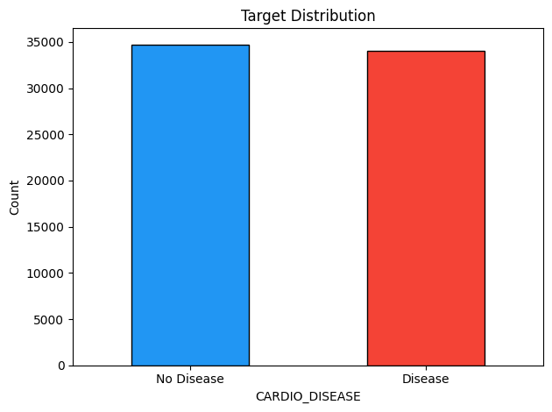
Figure 1. Target distribution from the shared EDA/preprocessing notebook. The class balance is close, which makes accuracy and F1-score more informative than in a highly skewed dataset.

3.2 Outlier detection and cleaning
The strongest cleaning pipeline was implemented in the broad benchmark notebook. It first removed biologically unrealistic values using direct thresholds, then applied an interquartile-range rule to the most sensitive measurements. The cleaning focused on blood pressure, height, and weight because these variables showed visible abnormal values before modelling. The thresholds kept AP_HIGH between 80 and 250, AP_LOW between 40 and 150, HEIGHT between 120 and 220, and WEIGHT between 30 and 200 before a second IQR pass was applied.
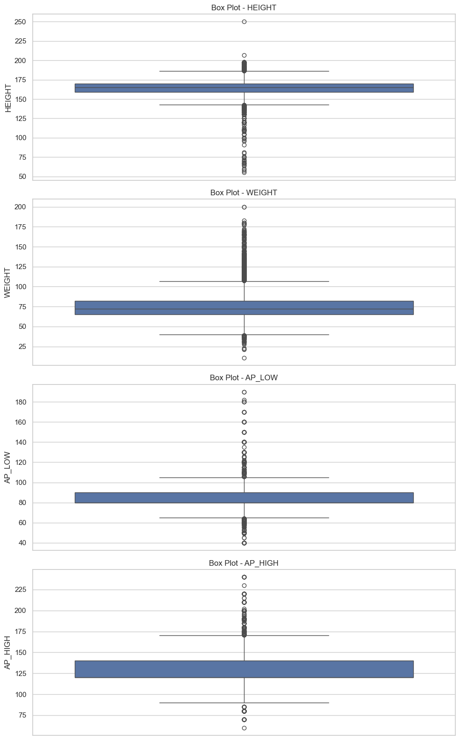
Figure 2. Boxplots before cleaning for HEIGHT, WEIGHT, AP_LOW, and AP_HIGH. The figure shows why blood pressure and body measurements required threshold filtering and IQR-based cleaning.
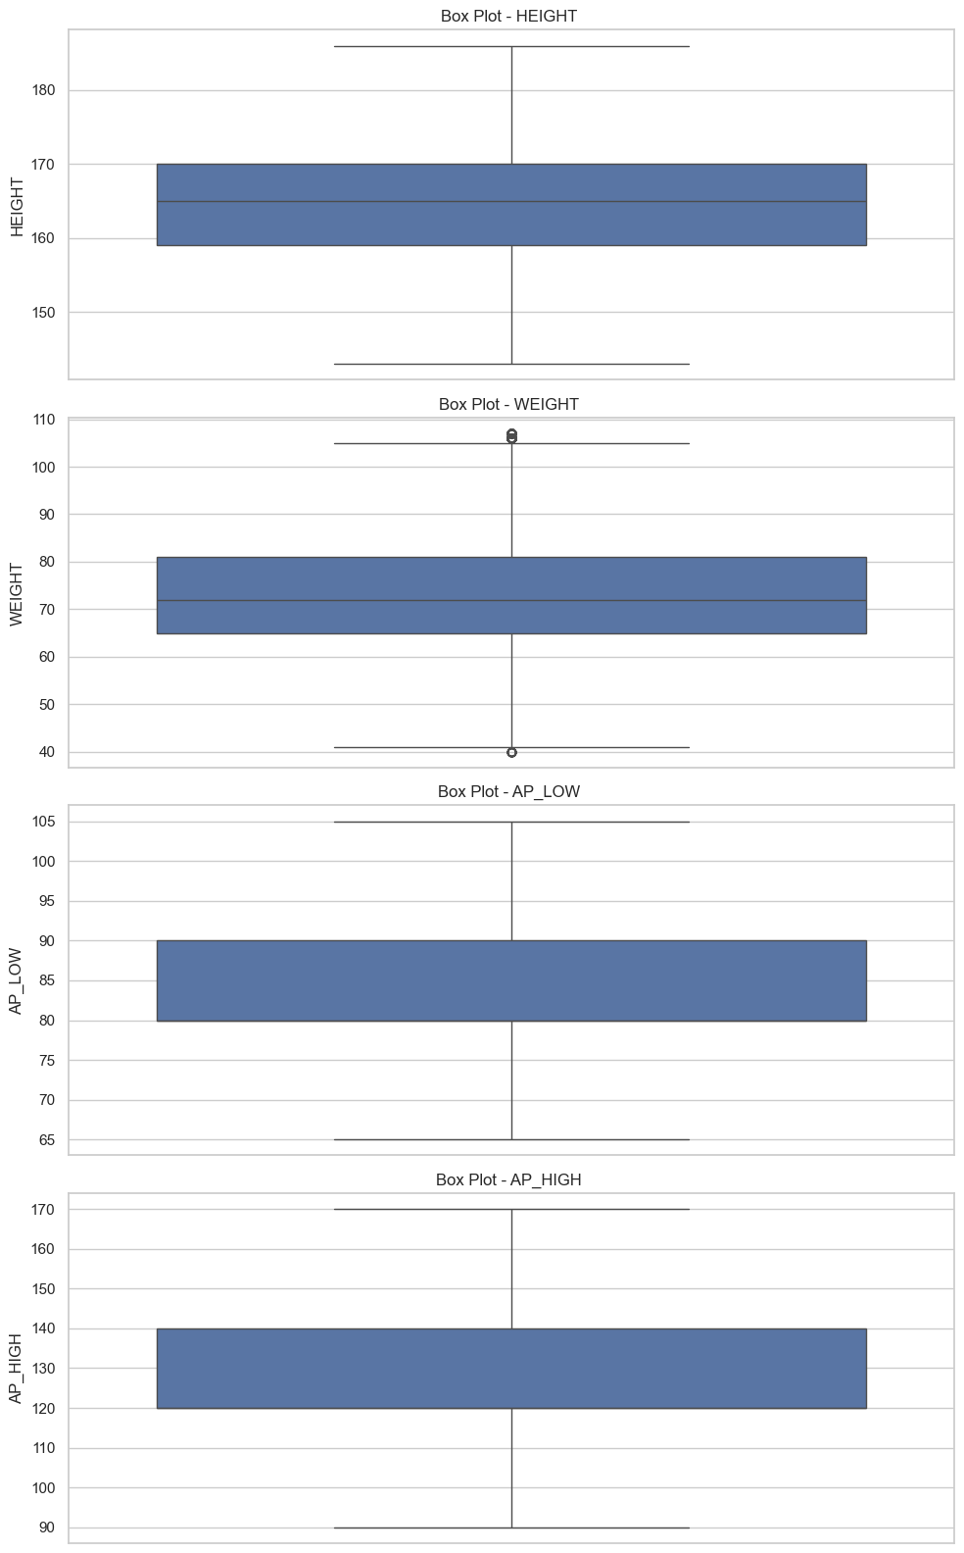
Figure 3. Boxplots after threshold filtering and IQR cleaning. The spread is more realistic and much less distorted by extreme values.

3.3 Distribution analysis and correlation structure
The notebooks used histograms, violin plots, scatter plots, and heatmaps to compare the two classes. The repeated pattern was clear: class differences were most visible in age, systolic blood pressure, diastolic blood pressure, cholesterol, glucose, and pressure-derived interaction features. The shared EDA notebook also ranked single-feature correlations with the target and showed AP_HIGH among the strongest direct predictors, which was later confirmed by the trained models and XAI methods.
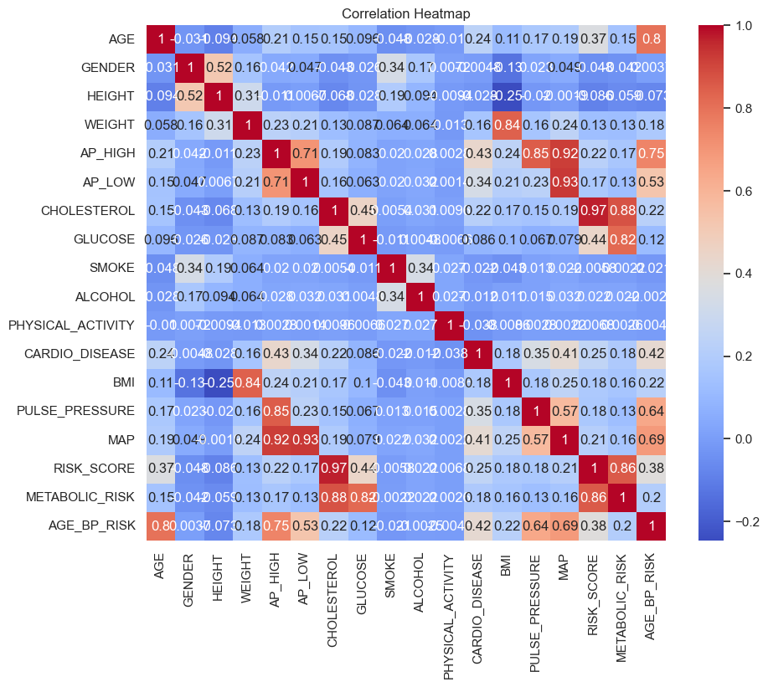
Figure 4. Correlation heatmap from the cleaned benchmark notebook. Age, blood pressure, and engineered pressure-risk variables form the strongest block of association with the disease label.
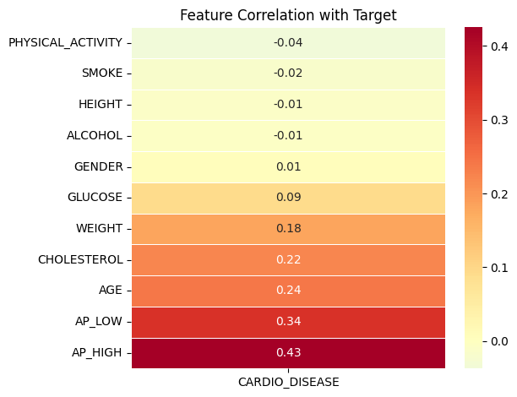
Figure 5. Feature-to-target correlation view from the XGBoost notebook. AP_HIGH has the strongest direct correlation with the target in that notebook, followed by AP_LOW and AGE.

3.4 Feature engineering
Feature engineering was a major shared theme. The team created BMI, pulse pressure, mean arterial pressure (MAP), age-pressure risk, metabolic combinations, and interaction terms such as BP_CHOL_INTERACTION and AGE_BMI_INTERACTION. These additions made the clinical logic of the problem easier to express. In the broad benchmark notebook, AGE_BP_RISK and MAP showed the strongest engineered correlations with the target. In the Shah-inspired boosting notebook, BP_CHOL_INTERACTION and AGE_BMI_INTERACTION were highlighted as helpful interaction signals.
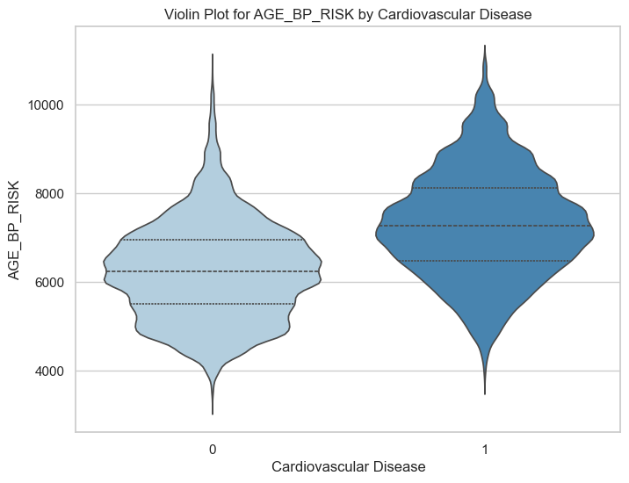
Figure 6. Violin plot for AGE_BP_RISK by cardiovascular disease class. The separation is stronger than for many raw variables, which explains why this engineered feature repeatedly appeared in feature-selection and importance results.

4. Model Development and Results
The team’s modelling strategy was intentionally diverse. Instead of relying on a single algorithm family, the notebooks tested classical machine learning, neural networks, boosted trees, a modified 1D CNN, a voting ensemble, and a stacking ensemble. This produced a useful comparison between simple baselines, more expressive non-linear models, and ensemble architectures motivated by recent cardiovascular disease papers.

4.1 Broad benchmark notebook: base features vs engineered features
The broadest notebook trained Random Forest, AdaBoost, SVM, ANN/MLP, and a modified 1D CNN on both a base-feature dataset and an engineered-feature dataset. On the base-feature version, the modified 1D CNN achieved the highest reported accuracy, while the ANN/MLP gave the strongest disease-class recall and the highest ROC-AUC. SVM was also competitive. When engineered features were added, the overall numerical performance did not improve, even though clinical interpretability became richer. This suggests that some of the new variables were more useful for explanation than for predictive gain.
Model (base features) | Accuracy | Precision | Recall | F1-score | ROC-AUC
Random Forest | 0.7258 | 0.7363 | 0.6953 | 0.7152 | 0.7870
AdaBoost | 0.7153 | 0.7650 | 0.6135 | 0.6809 | 0.7873
SVM | 0.7327 | 0.7628 | 0.6677 | 0.7121 | 0.7913
ANN / MLP | 0.7333 | 0.7455 | 0.7004 | 0.7222 | 0.8002
Modified 1D CNN | 0.7349 | 0.7668 | 0.6677 | 0.7138 | 0.8001

Model (engineered features) | Accuracy | Precision | Recall | F1-score | ROC-AUC
Random Forest | 0.7118 | 0.7220 | 0.6772 | 0.6989 | 0.7718
AdaBoost | 0.7173 | 0.7635 | 0.6194 | 0.6840 | 0.7843
SVM | 0.7268 | 0.7655 | 0.6440 | 0.6996 | 0.7788
ANN / MLP | 0.7245 | 0.7384 | 0.6849 | 0.7106 | 0.7895
1D CNN | 0.7244 | 0.7433 | 0.6751 | 0.7076 | 0.7902

The most important interpretation from these tables is not just which model had the highest accuracy. In a disease-prediction setting, recall matters because it tells us how many true disease cases were actually detected. A model with slightly lower accuracy but noticeably better recall may be safer for screening. That is why the ANN/MLP result in the base-feature experiment deserves attention even though the 1D CNN had the highest accuracy.

4.2 Ogunpola-inspired tuned XGBoost notebook
The second notebook first justified the selection of Ogunpola et al. (2024) over two alternative papers because it matched the clinical tabular structure of the team dataset. The implementation then strengthened XGBoost through nine hyperparameter changes, including a larger number of trees, a lower learning rate, deeper trees, row and column subsampling, min_child_weight, gamma, and L1/L2 regularisation. The resulting tuned model was then compared on engineered and original data and followed by SHAP-based explanation.
XGBoost variant | Accuracy | ROC-AUC | Interpretation
Engineered-data tuned XGBoost | 0.7276 | 0.7958 | Competitive but slightly below the original-data version
Original-data tuned XGBoost | 0.7297 | 0.7973 | Slightly stronger overall result in this notebook

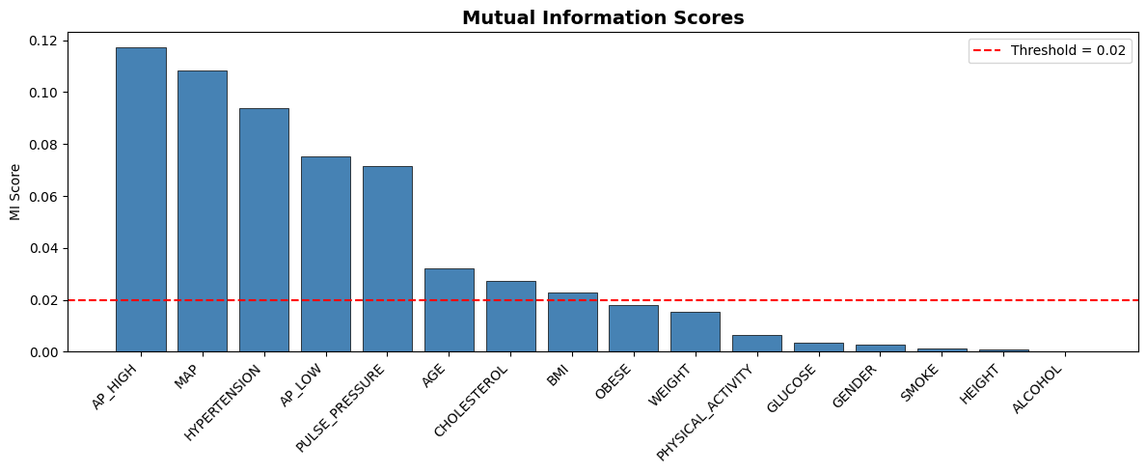
Figure 7. Mutual-information ranking from the XGBoost notebook. AP_HIGH, AGE, and CHOLESTEROL stand out among the most informative variables before final model interpretation.
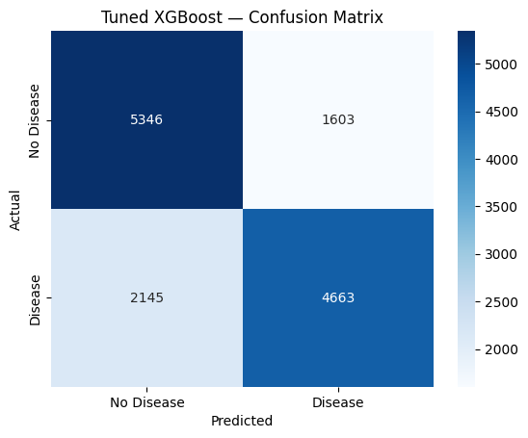
Figure 8. Confusion matrix for tuned XGBoost on the engineered-data setting. The matrix shows the trade-off between true disease detection and false negatives.

4.3 Shah-inspired boosting and soft voting notebook
The Shah-inspired notebook adapted the idea of combining strong tabular models with explainability. It implemented XGBoost, LightGBM, CatBoost, Random Forest, Gradient Boosting, Logistic Regression, and a soft voting ensemble, together with SMOTE balancing. The results clustered tightly, which suggests that the dataset is learnable but not easy to push far beyond the high-0.79 AUC range without additional tuning or a more powerful meta-learner.
Model | Accuracy | Precision | Recall | F1 | ROC-AUC
XGBoost | 0.7290 | 0.7455 | 0.6870 | 0.7150 | 0.7975
LightGBM | 0.7295 | 0.7458 | 0.6879 | 0.7157 | 0.7984
CatBoost | 0.7299 | 0.7473 | 0.6863 | 0.7155 | 0.7994
Random Forest | 0.7283 | 0.7458 | 0.6842 | 0.7137 | 0.7977
Gradient Boosting | 0.7278 | 0.7427 | 0.6885 | 0.7145 | 0.7970
Logistic Regression | 0.7234 | 0.7385 | 0.6829 | 0.7096 | 0.7876
Voting Ensemble | 0.7290 | 0.7458 | 0.6864 | 0.7149 | 0.7987

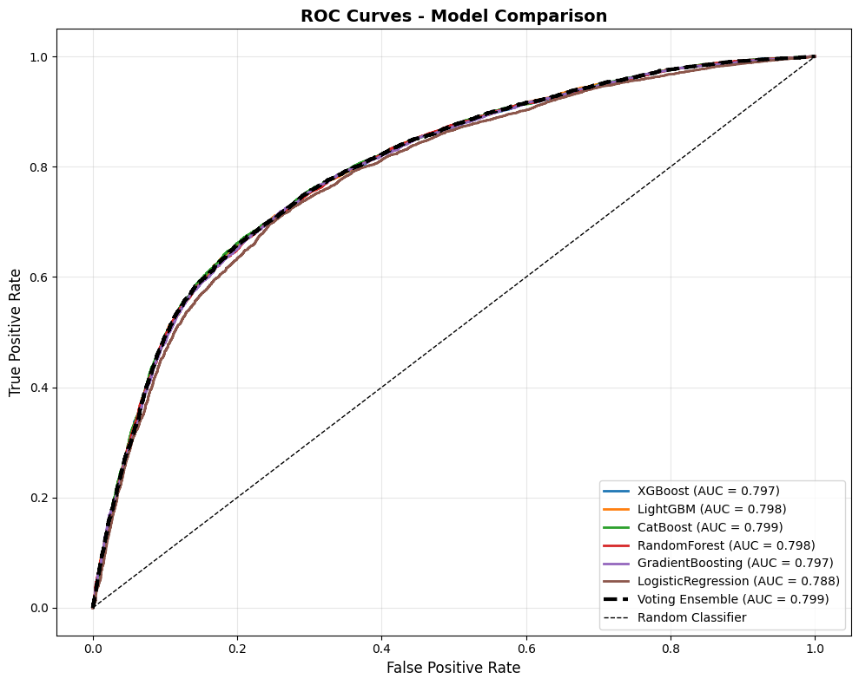
Figure 9. ROC-curve comparison from the Shah-inspired notebook. The curves show that the boosting models are very close, with only small separations in AUC.

4.4 Stacking notebook
The fourth notebook focused on three paper-motivated models: Logistic Regression, SVM, and a stacking ensemble composed of Random Forest, Extra Trees, MLP, and CatBoost with Logistic Regression as the meta-learner. This notebook reported the strongest combined result among the four reports, with the stacking model achieving 0.7375 accuracy and 0.8062 AUC. This result supports the idea that combining diverse learners helps stabilize the decision boundary and improve discrimination on this dataset.
Model | Accuracy | AUC | Note
Logistic Regression | 0.7318 | 0.7960 | Baseline and meta-learner
SVM | 0.7366 | 0.7958 | Strong non-linear baseline
Stacking Ensemble | 0.7375 | 0.8062 | Best combined result reported across the team summaries

4.5 Why recall matters in this disease task
Recall measures the proportion of real disease cases that the model correctly identifies. In this project, the positive class represents patients who actually have cardiovascular disease. A false negative therefore means that a patient with disease was predicted as no disease. In clinical practice, this can be costly because the patient may miss timely intervention or follow-up testing. For that reason, recall should be interpreted carefully alongside accuracy. A model that improves recall can be more valuable in a screening setting even if its total accuracy is only slightly lower.

5. Interpretability Techniques and Results
A major strength of the team submission is that it does not stop at prediction. The notebooks collectively implement a broad set of interpretability techniques that explain both global model behavior and local patient-level decisions. These methods repeatedly pointed to the same clinical story: blood pressure, age, cholesterol, and engineered pressure-based interaction features dominate the model’s logic.

5.1 Feature selection and multicollinearity
Recursive Feature Elimination (RFE) and Variance Inflation Factor (VIF) were used in the broad benchmark notebook. RFE with both Random Forest and Logistic Regression repeatedly selected AGE, AP_HIGH, MAP, RISK_SCORE, and AGE_BP_RISK, which indicates that these variables carry stable predictive value across modelling assumptions. VIF analysis then revealed that several engineered variables had very high or infinite VIF values because they were direct mathematical combinations of other predictors. This explains why feature engineering improved explanation quality more than raw performance.
RFE method | Important selected features
Random Forest RFE | AGE, HEIGHT, WEIGHT, AP_HIGH, BMI, MAP, RISK_SCORE, AGE_BP_RISK
Logistic Regression RFE | AGE, AP_HIGH, AP_LOW, CHOLESTEROL, PULSE_PRESSURE, MAP, RISK_SCORE, AGE_BP_RISK

5.2 SHAP explanations
SHAP was the most consistently emphasized XAI technique across the team. In the XGBoost notebook, the global bar plot, beeswarm plot, and waterfall plot showed that AP_HIGH, AP_LOW, and AGE were the strongest global drivers. The Shah-inspired notebook confirmed AP_HIGH as the dominant signal and added that BP_CHOL_INTERACTION and AGE_BMI_INTERACTION captured useful non-linear structure. The benchmark notebook’s Random Forest SHAP plots supported the same broad pattern: the models rely on age, blood pressure, cholesterol, and interaction terms rather than on arbitrary noise.
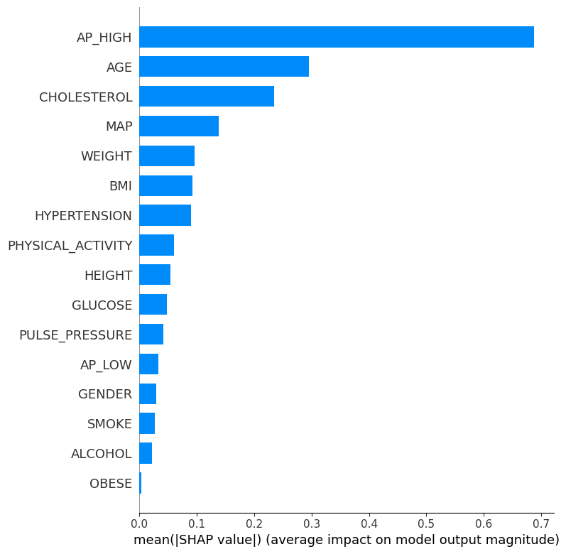
Figure 10. SHAP summary plot from the tuned XGBoost notebook. Higher systolic pressure and older age consistently push predictions toward cardiovascular disease.
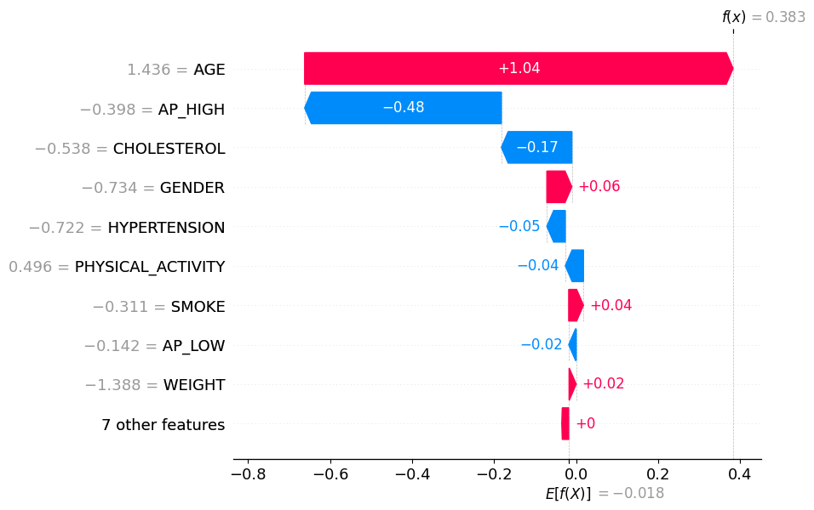
Figure 11. SHAP waterfall explanation for one tuned XGBoost prediction. The plot shows how the model moves from the baseline probability to the final prediction through additive feature contributions.
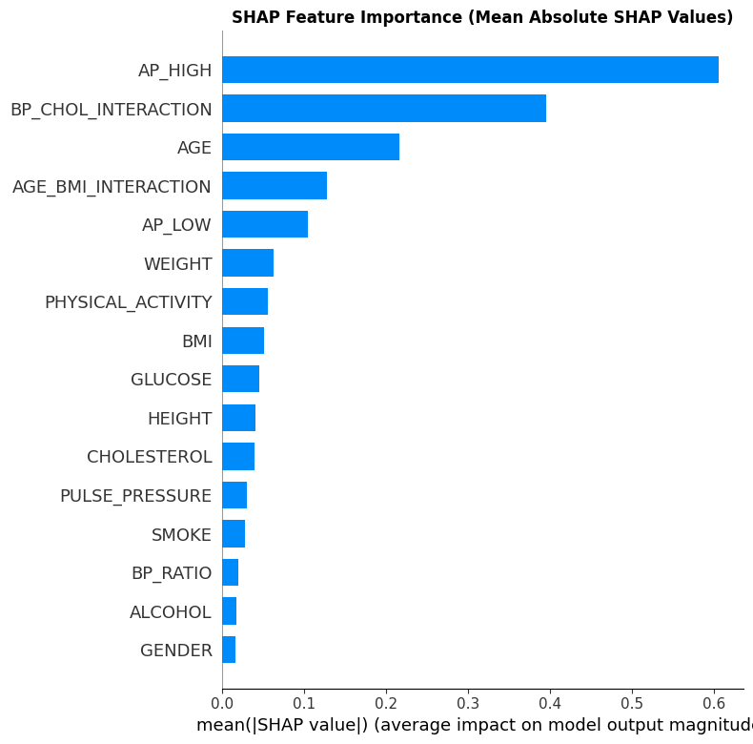
Figure 12. SHAP mean absolute importance from the Shah-inspired notebook. AP_HIGH, BP_CHOL_INTERACTION, AGE, and AGE_BMI_INTERACTION stand out as major contributors.

5.3 Permutation importance and built-in feature importance
Permutation importance was valuable because it provided model-agnostic global rankings across several algorithms. In the benchmark notebook, Random Forest, MLP, SVM, and the modified 1D CNN all ranked AP_HIGH, AGE, CHOLESTEROL, AGE_BP_RISK, MAP, PULSE_PRESSURE, and RISK_SCORE near the top. The stacking notebook also used permutation importance and again highlighted AP_HIGH, AGE, and CHOLESTEROL. Although impurity-based feature importance from Random Forest differed slightly in ranking, it still pointed to blood pressure, body-mass-related variables, and age-pressure interactions as dominant signals.
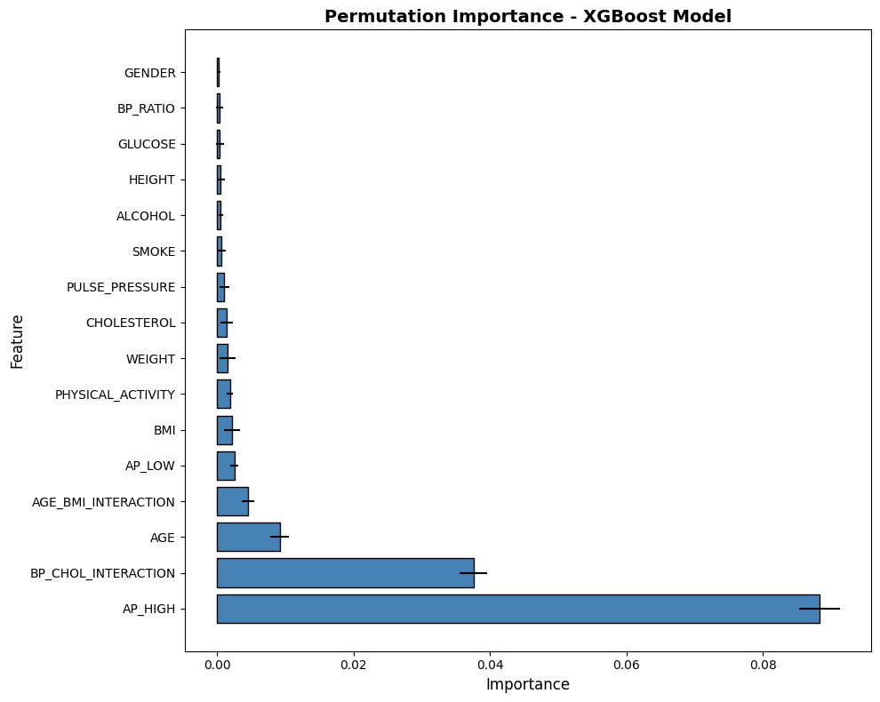
Figure 13. Permutation importance from the Shah-inspired notebook. AP_HIGH dominates the model-agnostic ranking by a clear margin.
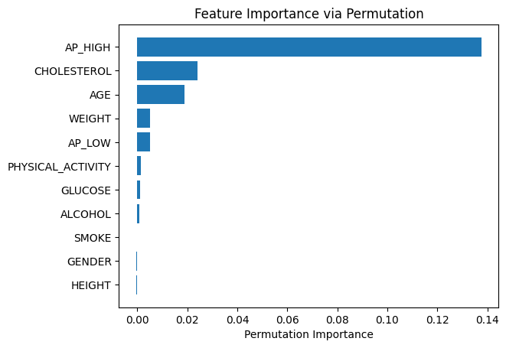
Figure 14. Permutation importance from the stacking notebook. AP_HIGH, CHOLESTEROL, AGE, and WEIGHT again appear as the strongest drivers.

5.4 LIME explanations
LIME was used in the Shah-inspired and stacking notebooks to explain why a single patient-level prediction moved toward disease or away from it. This is useful because it complements SHAP’s global ranking with an intuitive local explanation. The local plots consistently showed that high AP_HIGH, higher age, and worse cholesterol status increase the disease score, while healthier counter-signals such as physical activity or lower blood pressure push the prediction back toward no disease.
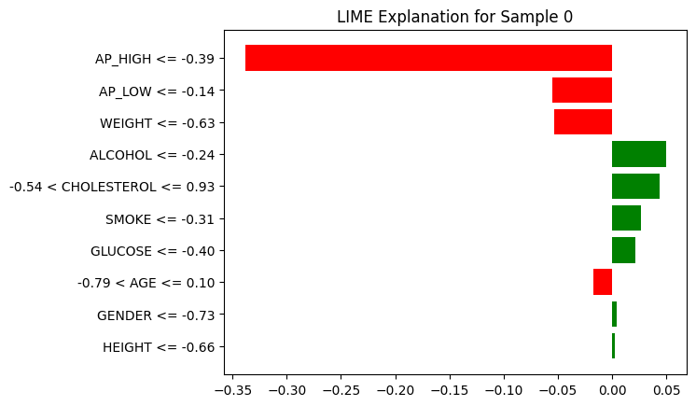
Figure 15. LIME explanation for one sample from the stacking notebook. Red bars push the case toward disease, while green bars reduce the predicted risk.

5.5 PDP and ICE plots
Partial Dependence Plots (PDP) and Individual Conditional Expectation (ICE) plots translated the model into clinically understandable patterns. Across notebooks, the PDP curves showed that risk generally rises with higher AP_HIGH, higher cholesterol, and older age. The ICE plots added an important nuance: not every patient follows the same path, which means the models capture patient-specific differences rather than only a single global average relationship.
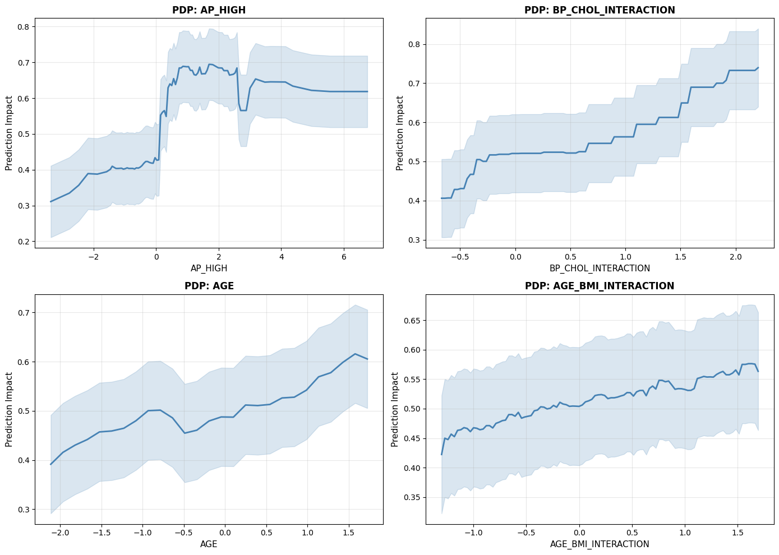
Figure 16. PDP grid from the Shah-inspired notebook. As AP_HIGH and interaction-based risk features rise, predicted cardiovascular disease probability also rises.
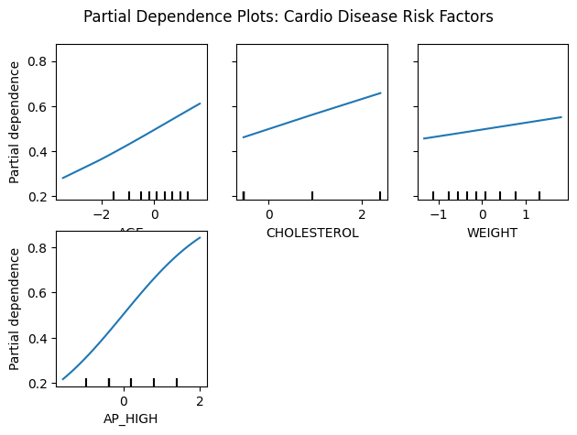
Figure 17. PDP examples from the stacking notebook. AGE, CHOLESTEROL, and AP_HIGH all show a positive relationship with predicted disease risk.

6. Discussion
Looking across the four notebooks, several conclusions are consistent. First, EDA was not a cosmetic step; it was necessary to detect biologically unrealistic values and to justify outlier-aware cleaning. Second, no single model dominated every metric. The stacking ensemble produced the strongest combined result, the modified 1D CNN and MLP were strong in the broad benchmark notebook, and CatBoost and LightGBM were robust among the boosting models. Third, feature engineering improved clinical readability more than raw predictive accuracy because some new variables added redundancy. Finally, the interpretability results were remarkably stable across model families, which increases trust in the learned patterns.
- Most stable risk signals: AP_HIGH, AP_LOW, AGE, CHOLESTEROL, GLUCOSE, and pressure-based interaction terms.
- Most important clinical metric for screening use: recall, because missed disease cases correspond to false negatives.
- Best reported combined result across the team summaries: stacking ensemble with 0.7375 accuracy and 0.8062 AUC.
- Best non-ensemble benchmark results: modified 1D CNN for accuracy in the broad benchmark notebook and ANN/MLP for disease-class recall.

7. Conclusion
This unified report demonstrates a complete and interpretable workflow for cardiovascular disease prediction. The team covered the full pipeline: data inspection, cleaning, outlier handling, feature engineering, model comparison, and explanation of results. Even though the exact best model changed from notebook to notebook, the medical interpretation remained consistent. The models learn clinically meaningful patterns centered on blood pressure, age, cholesterol, glucose, and derived blood-pressure interaction features. This is the most important outcome of the project because it shows that the team did not only optimize model scores; it also built evidence that the predictions are medically plausible and explainable.

References Used by the Team Reports
- Ogunpola et al. (2024). Machine Learning-Based Predictive Models for Detection of Cardiovascular Diseases.
- Shah et al. (2025). Predicting cardiovascular risk with hybrid ensemble learning and explainable AI.
- Baghdadi et al. (2023). Advanced machine learning techniques for cardiovascular disease early detection and diagnosis.
- Tompra et al. (2024). Strategic Machine Learning Optimization for Cardiovascular Disease Prediction and High-Risk Patient Identification.
- Khan Mamun, M. M. R., & Elfouly, T. (2023). Detection of Cardiovascular Disease from Clinical Parameters Using a One-Dimensional Convolutional Neural Network. Bioengineering, 10(7), 796. https://doi.org/10.3390/bioengineering10070796

